**Download MySQL**

MySql is an OpenSource database available for download from the Internet.

The main site is: <http://www.mysql.com/>

The software is available for download at: <http://dev.mysql.com/downloads/>

The version we will download is the MySQL Community Server. Notice that is has a (GPL) after it. This is a reference to the license of the software.

GPL is the initials for Gnu Public License. The GPL is a common means of licensing software for open use. The significant terms of the GPL are:

1. Anyone can use the software.
2. Anyone can redistribute the software, provided they maintain the license and provide access to the source code.
3. Anyone can alter the source code, provided they maintain the GPL on unaltered code. There are pages and pages of specific details.

When you click on the Download button, you will go to another page. Follow the directions for the recommended downloads.

After you have completed the download of either the full product, or the web-installer, start the installation process. One of the first things you will see is the License Agreement. If you are not familiar with GPL, I would urge you to read the license to see what it covers.

When asked for the ***Setup Type***, select ***Developer Default***.

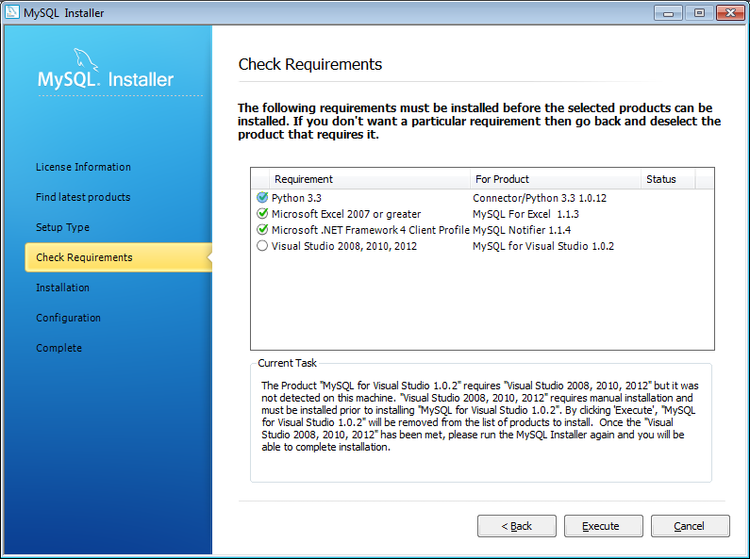The installer will notice that you need to install Visual Studio (it may also have other items it lists as required). Unfortunately, the installer doesn’t recognize Visual Studio 2013 (see image).

If you click ***Execute***, the installer will move skip ahead and give another check requirements window. If there are other items on the list of requirements which are not installed (do not have a green check) the installer will skip them as well. The result will be that those related capabilities will not work in the installation.

Clicking ***Next*** on the new Check Requirements window will bring up the Installation Progress window. To start the installation, click ***Execute***.

When installation is complete, we can move on to configuration.

The first configuration is for MySQL Server. Choose to install a development machine. The other options will consume more resources on your computer. TCP/IP Networking is not required, but makes life easier. We will not need to set any advanced options.

On the next window, be sure to set a good strong password and make sure you record it somewhere you can retrieve it when you forget it.

We will also create a user since we will not want to use root as the user from our programs. That would create a significant security hole. Since we will be creating tables from our programs, we will give the user we create the ***role*** of ***DB Admin***. Remember to create and stash away a secure password.

On the next window, copy down the Windows Service Name you use (default is ok). The easiest choice is to start the server at system startup. Otherwise, you will later wonder why things don’t work. But if you like to keep your system with minimal process running, you can start MySQL manually whenever you need it.

Configuration of Samples and Examples may not require any input.

Once the system installs, keep the checkbox marked to open the ***MySQL Workbench.***  This is a tool which allows you to work with SQL Databases. If you haven’t had the box checked, the ***MySQL Workbench*** can be opened from the ***Start Menu***.

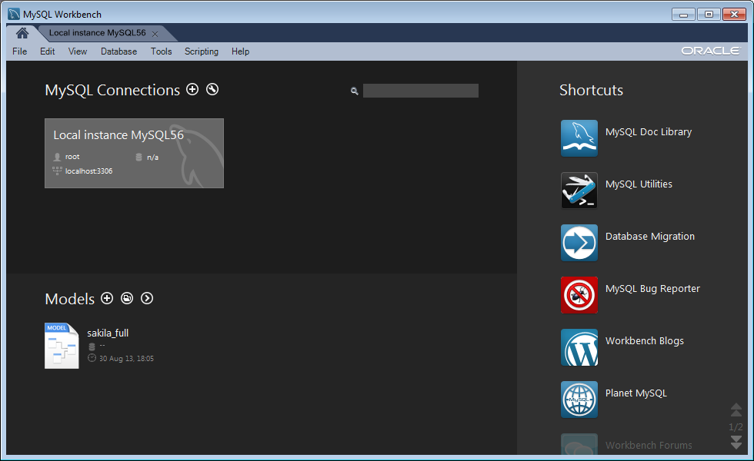

Click on the Local instance of MySQL56. You will get a navigation screen like this:

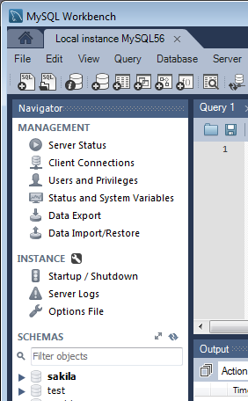Toward the bottom of the ***Navigator*** pane will be a list of the schemas that are in the database server. If you don’t see the schemas, you may need to use the mouse to slide down the divider between the ***Navigator*** pane and the ***Information*** pane below it.

The currently selected schema is highlighted. In this case it is the sakila schema. A schema is a particular database managed by the Database Management System (DBMS).

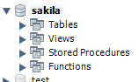The sakila and test schemas are put in place by the installer to support samples and demos of the DBMS. Click on ***sakila***.

Now you will see a list of database objects. You can click on these to expand them.

Next right click on the actor table. And select “Select Rows – Limit 1000”. A pane with the table data will open up in the Workbench. Go ahead and get familiar with what is in the database.

**Loading a New Database**

The sample databases provided with the default MySQL installation do not include the database we want to use. This will be one called ***world***. The world schema and data (remember the schema defines the structure of the database, the data is the content) are available from the MySQL website. The url is: <http://dev.mysql.com/doc/index-other.html> . Look under ***Example Databases***. Choose the first (MyISAM version) world database. Select either Gzip or Zip version and download.

If you do not have uncompression software on your computer you will need to get a copy. One alternative is Filezilla at: <https://filezilla-project.org/> There are many other alternatives also available.

Once you have downloaded and uncompressed the database, follow the instructions at: <http://dev.mysql.com/doc/world-setup/en/index.html> to load the database into your installation of MySQL. Then poke around in the new database to become familiar with its contents.